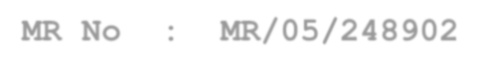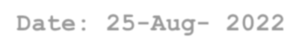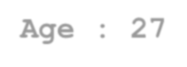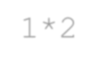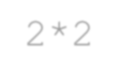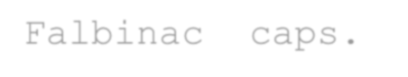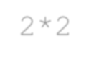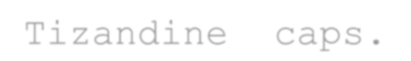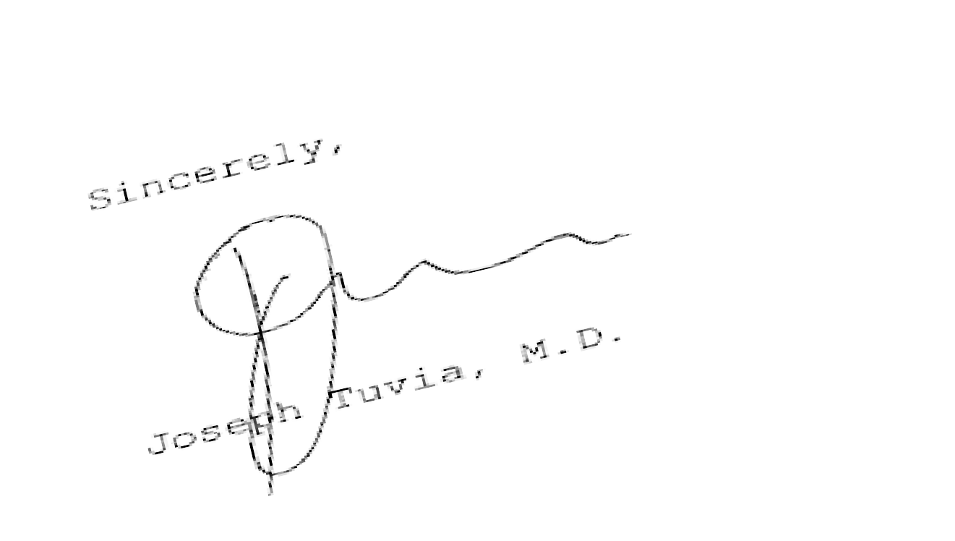

C Road, West, Northern Town, Bistupur, Jamshedpur-831 001, Jharkhand, India



* Tel:-0657 - 6641099, 6641109

website:[www.tatamainhospital.com](http://www.tatamainhospital.com/)

* Diagnostic Services - Department of Orthopedics

TMH/ FRM/ CLIN/ OPD/162 Effective date – 25-08-2022

**MR No : MR/05/248902 Date: 25-Aug- 2022** 11:17:21

**Pat No : OP/29/627039**

**Name : Nisha Kumari Singh Age : 27 Sex:F**

**Ref Dr : Joseph Tuvia, M.D.**

* Patient has been diagonised with the visisble deformatives in ankle and the dislocation of lunate bones.

# Advise :

* Patient is advised not to make the sideways movement of knee along with the ankle and take a proper rest for 5-7 days.

# Medicine:

* Acemetacin caps. 1*2
* Dantrolene tabs. 2*2
* Falbinac caps. 2*2
* Tizandine caps. 2*2